NEA Project Ideas

1. Simulation of A particle Accelerator
   1. This is my main idea as it links particle physics into my project. It will take the for of a simulation where many different variable can be set and a multitude of deferent endings can be produced. I would like to make this visual to the effects of the photo shown below.

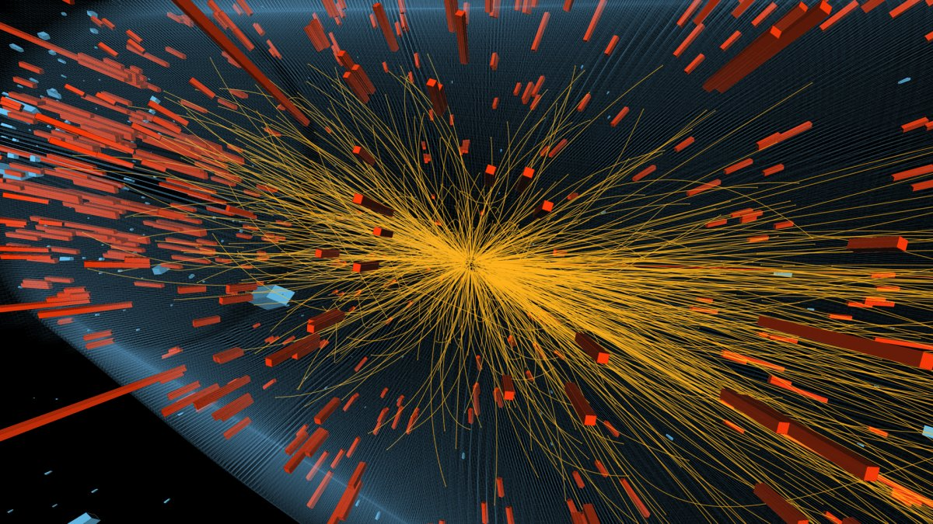

I understand this sort of visual representation will be very complicated and can be simplified into a 2D setting. Data will on the particles will be held in objects and I want values in them to be partially randomised yet repeatable upon the test running. This project will also require extra work into the products of particle collisions but I am more than happy to put in the extra work for it. The program will be designed for students who are studying particle physics and may include other information on top of the simulation but only if time allows. The main problem with this program would be the visual aspect as the storing of data and the outputting of it under certain situations will be challenging but doable. Whereas the visual diagram will take a lot of time to implement. It should run on a semi-random design.

1. A military battle plan application
   1. This one could be interesting as it can hold a couple of different projects in one. This application would produce a map of a location (A bit far fetched I know! / Could take an image of an OS map and use that as a back ground) and allow units to be placed onto the map. Each “Unit” will hold a lot of information on itself, plus the likelihood of success against enemy. Based on there’s predictions there would be a separate option that would allow the user to send encrypted emails of orders to subordinates. (The encryption will have to be of my own design). The program would be designed for the modernising and streamlining of Battle prep and Orders from Battle Group’s to Company’s. I am unsure of how to be able to load OS maps and append them. The “Units” will be objects with possibly a database behind them storing the information. (Possibly preset). Adding the ability to encrypt and email orders will add a good level of complexity to the program but could be very time consuming to implement.
2. Electronic filing System
   1. This program would allow to design their own storing system using databases that can be easily changed without compromising the data that it holds. This will require the user of tables that only hold links to separate areas but can provide the information stored when required and a way for the database to be altered without damaging the structure. This project will most likely use naked objects to work with the main focus being that separate users can create completely different databases which a called when a user logs on. The system could be used by anybody, especially where many users require different storage systems such as in a school. I am reasonable confident in implementing all of it. Just the storage of different databases could be intresting.